Bangladesh University of Engineering and Technology

Department of Computer Science and Engineering

**CSE 316 July 2022**

Microprocessors, Microcontrollers, and Embedded Systems Sessional

**Experiment 4**

**UART Communication Between ATmega32 and Arduino**

**GOAL:**

To understand the basic working principle of UART and external interrupt.

**EXPERIMENTAL TOOLS AND MATERIALS:** ATmega32, USBASP programmer, ArduinoUNO, Trainer Board, Wires, LED, Push Button.

**BASIC DESCRIPTION:**

In this experiment you will have to turn on a LED connected to ArduinoUNO depending on a push button connected to Atmega32. Atmega32 will send the state of the push button to ArduinoUNO using UART communication.

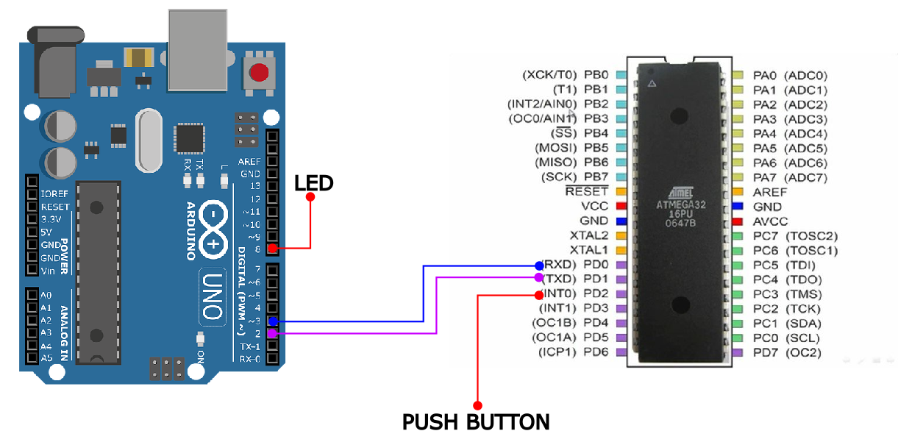

**UART (Arduino Atmega) Basics:**

Use the following code snippets for Atmega32 to send characters every 1 second.

#define F_CPU 1000000

#include <avr/io.h>

#include <util/delay.h>

void uart_init()

{

UCSRA = 0b00000010;

UCSRB = 0b00011000;

UCSRC = 0b10000110;

UBRRH = 0;

UBRRL = 12;

}

void uart_send(unsigned char data){

while ((UCSRA & (1<<UDRE)) == 0x00);

UDR = data;

}

unsigned char uart_receive(void){

while ((UCSRA & (1<<RXC)) == 0x00);

return UDR;

}

int main(void)

{

uart_init();

_delay_ms(1000);

while(1)

{

for(char c = 'a'; c <= 'z'; c++) {

uart_send(c);

_delay_ms(1000);

}

}

}

Use the following code snippet for ArduinoUNO to read the characters and print them on the Serial Monitor continuously.

#include<SoftwareSerial.h>

SoftwareSerial SUART(2, 3); //RX = DPin-2; TX = DPin-3

void setup() {

Serial.begin(9600);

SUART.begin(9600);

}

void loop() {

byte n = SUART.available();

if (n != 0)

{

char x = SUART.read();

Serial.print(x);

}

}

**PROCEDURE:**

1. Establish serial communication between Atmega32 and ArduinoUNO.
2. Connect a push button to Atmega32.
3. Connect a LED to ArduinoUNO.
4. On the press of the button, send a character from Atmega32 to ArduinoUNO. You must handle button logic with external interrupt.
5. Upon receiving the character, ArduinoUNO should toggle the LED.

**MISC:**

1. You should be prepared to communicate at any baud rate assigned to you during the experiment.
2. Study the provided code snippets. You must be able to modify them on demand.